Dying Light Review
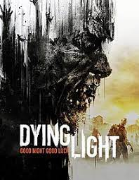
Welcome to my review of Dying Light Techlands third zombie game (Yes you saw correctly third) coming right after Dead Island (Original and Riptide)
They switched publishers on this one though due to the falling out with previous publisher Deep Silver, and opted to go through Warner Bros. Interactive Entertainment, which ensured a smoother and more creative process.
Oh boy what a good decision this was as well.

Parkour But With Zombies?
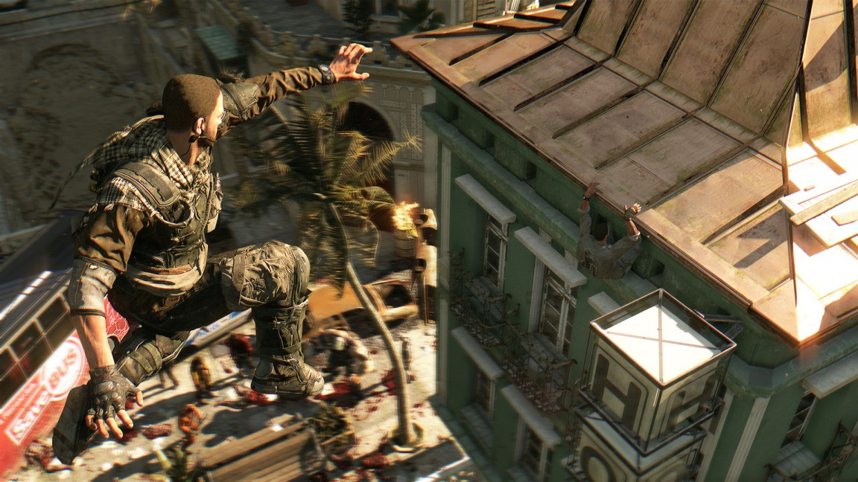
Albeit mixing parkour with zombies had never been done before, it pulled me right in to see how well the two would mix.
How the two would mix is what enthralled me to play for hours on end without shifting an inch.

Gameplay?

The game itself (although launched with one) has two game modes that is, story mode and be the hunter which is linked with the multiplayer, that makes you one of either four survivors or the hunter which is a powerful volatile (Powerful mutated night hunter)
The story in itself was both underwhelming and overwhelming at times.
You play as Kyle Crane, a undercover GRE operative, who has to go inside the city of Harran where a mysterious virus has broken out, to collect vital information from one Kadir ‘’Rais’’ Suleiman (A political figure) which may lead to cure. When once landed and settled in with his newly acquainted ‘’Enemies’’ he must choose between completing the mission or helping the survivors who have unfortunately been trapped without any contact to the outside world.
The game is still regularly updated, both with game improvements and DLC (both free and paid)
Combat in this game is 100% the best i've yet to play in any Melee driven game, from slicing limbs off to drop kicking zombies from buildings has to be the most satisfying thing I have ever witnessed in a game before.
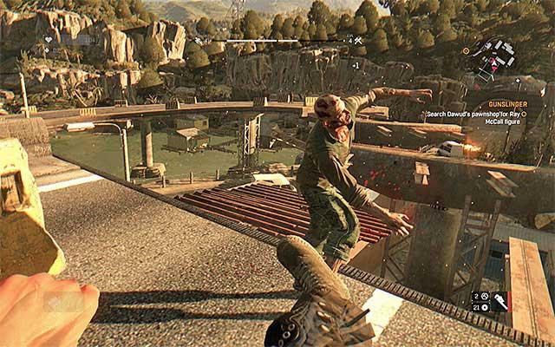
Although the parkour could be touched on, it still holds up from climbing shacks to climbing 3 and or 4 story buildings, it made me think of unusual ways to get from A to B, which is good for a game to do.
What i do not think the game bodes well with is gunplay, they feel jagged and do not hold up well for a game of the years previous to so (Far Cry 4,CoD and Halo TMCC ect ect)

Graphics & Audio

Dying Light is still one of the most beautiful exotic games I have played.
From sunny days to rainy afternoons, nothing is too overpowering which at times can make the game look dull, but there are pure moments of beauty within the game especially with the Xbox Series S which I am playing on.
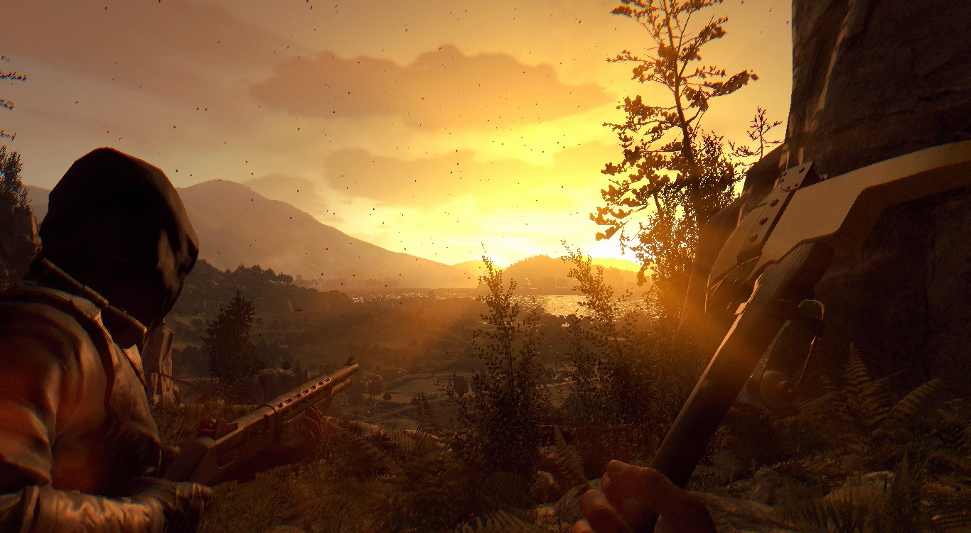
Now with the audio it is immaculate, from the sound of your footsteps to the grone of the zombies behind you ready to pounce, everything fits together perfectly, the only thing i was let down with was the music choice, it felt to upbeat and techy for a dystopian city in crisis (That may just be me though haha!).
What i tend to drift back to is the individual parts on the zombies body and how whatever way you swing your weapon is how the body reacts, this could mean you could swing a machete in the same direction but if the arm was in the way it would result in a different outcome (i.e slicing in half or taking the forearm off)

Longevity

As previously stated i have sunk a favourable amount of hours in this game and as a result i feel my review has stated both good and bad about the game (for me good outweighing the bad)
The game as a whole is great, with everything together, the story, DLC and multiplayer/co-op it makes something that had not been achieved before and for that it has made me so much more excited for the release of Dying Light 2.
I would definitely recommend this game to anyone who wanted a surreal zombies experience!
Final Thoughts

Without being biassed in my own opinion this game is single handedly up there with the greats of zombie games, Techland had really pulled this one out of the bag.
Whilst being regularly updated with more things to do it has me all ready for the release of Dying Light 2 which releases 4th February 2022
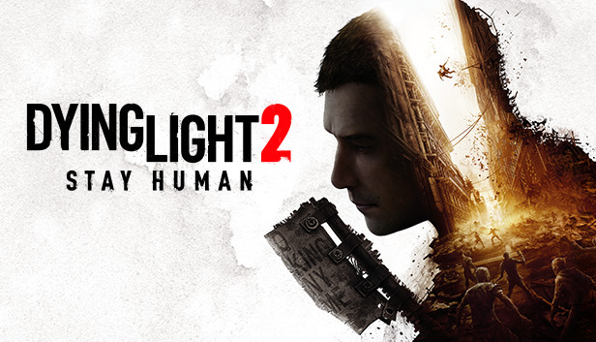
Rightly so this deserved Thumb Culture Platinum Award

I've been James and thank you for taking the time out of your day to read this review of Dying Light.

