After The Fall - Game Review

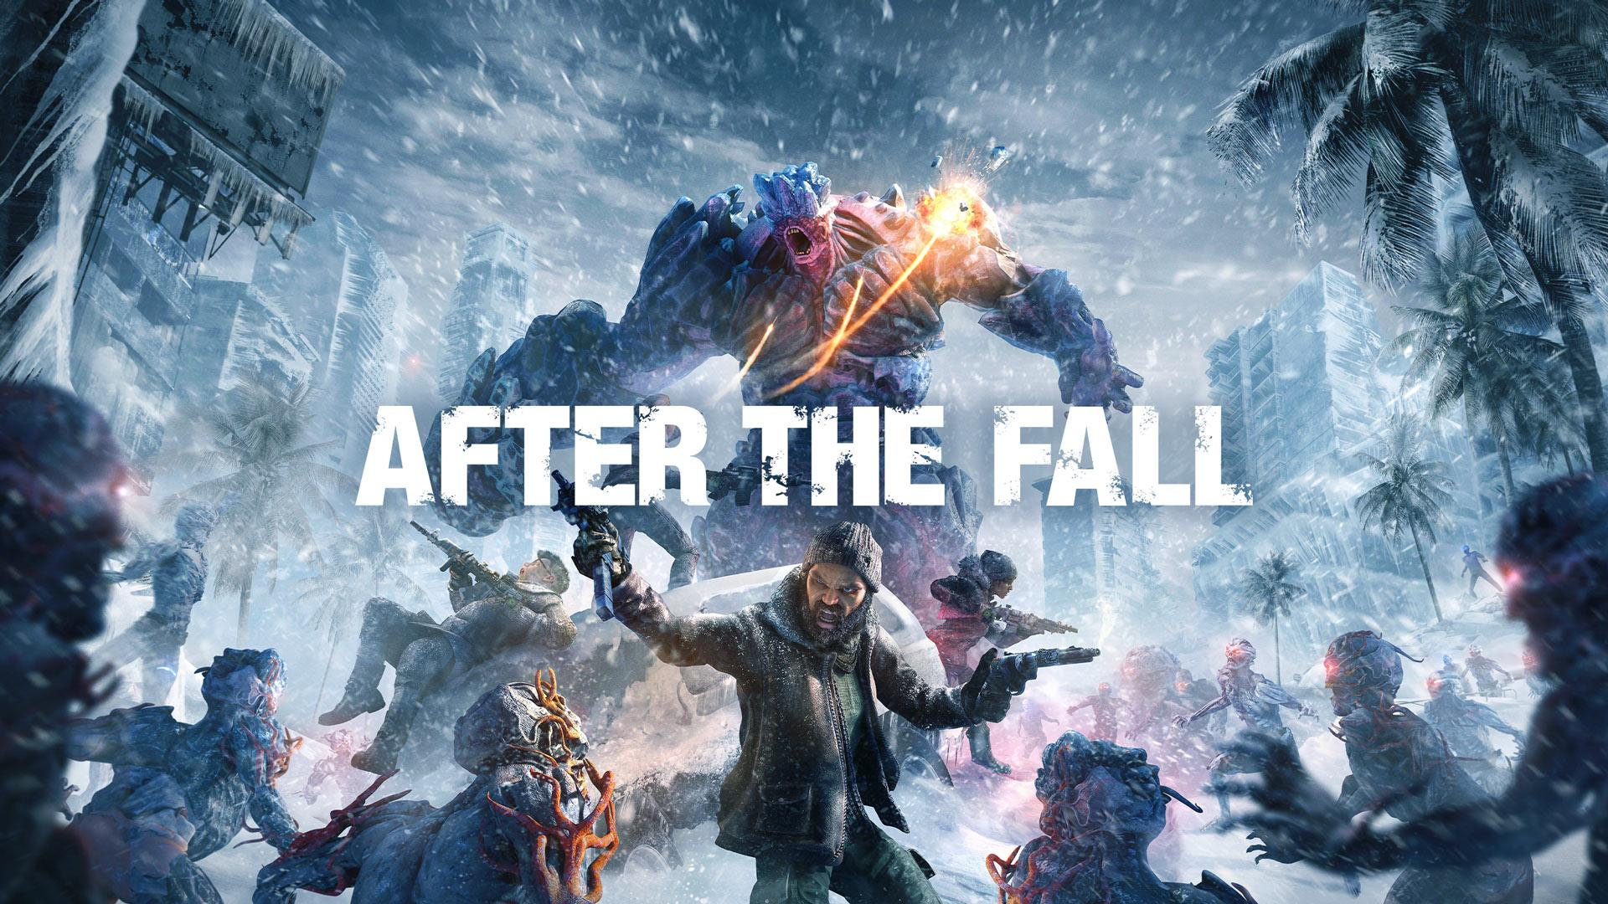

Welcome to my review of After The Fall. This is a new VR game and was developed and published by Vertigo games (creators of Arizona sunshine). This is a game full of potential especially when it is like Left 4 Dead and Back 4 Blood.
A VR version of those games were definitely needed, now I can actually feel like I'm there slaying the zombies in a snowy apocalypse.

Left 4… Oh wait After The Fall

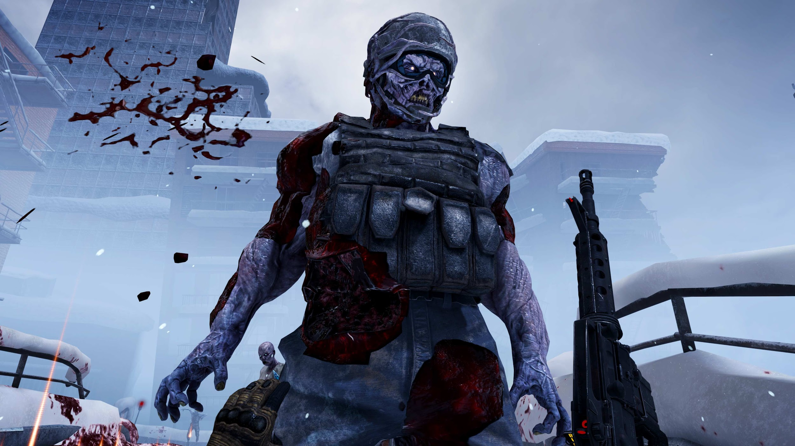

As previously stated the game structure is quite similar to L4D and the likes, this albeit is not a bad thing due to the increasing pressure of those games to come back. You know the ‘’old’’ go from A to B but have safe houses scattered in the middle.
This is not a bad plot either, the safe houses in the middle can be used to spend your harvest (currency from zombies when killed) on things like health boosters or pipe bombs.
It can become repetitive at stages as all games can but especially on the Quest 2 it does as you stand for a long time fighting waves of zombies, trying not to knock anything over whilst you frantically try to kill zombies…

Gameplay

Where to start but the start, Right off the bat you’re asked to configure your way of playing, how high your gun belt is, sitting or standing and reload type.
This is where for the first time in my VR playing career I chose the quick reload type…
This started an event which led to me choosing the realistic type of reload to then spend 10 minutes figuring how to reload and immediately switching this back to a one button reload.
So after my commotion, the story started with the safehouse opening up to save a survivor. This then led to an endless wave of enemies swarming you until dead, to which a man busts through them all in a truck to save you and bring you back to the ‘hub’ main menu in essence where you can choose your game mode, customize your gun and meet with friends.
There are two game modes in the game, which can be played online with other people or offline with the AI, you can play the normal harvest run or the team battles.
The only thing is that there is only 5 levels and they relatively don't take that long to do (30-40 minutes) and after that all that is left to do is replay through at a harder difficulty or have a go at the PvP mode (The fun can only last so long)
There is also no plot to this game, just simply drop into the game and play until the end, with only five levels to play this can be boring as there is no sense of meaning behind what you're doing apart from collecting harvest.
And although chaotic the weapon customisation is quite nice to play around with from stripping your weapon to the core, to then making it your own personal killing machine.

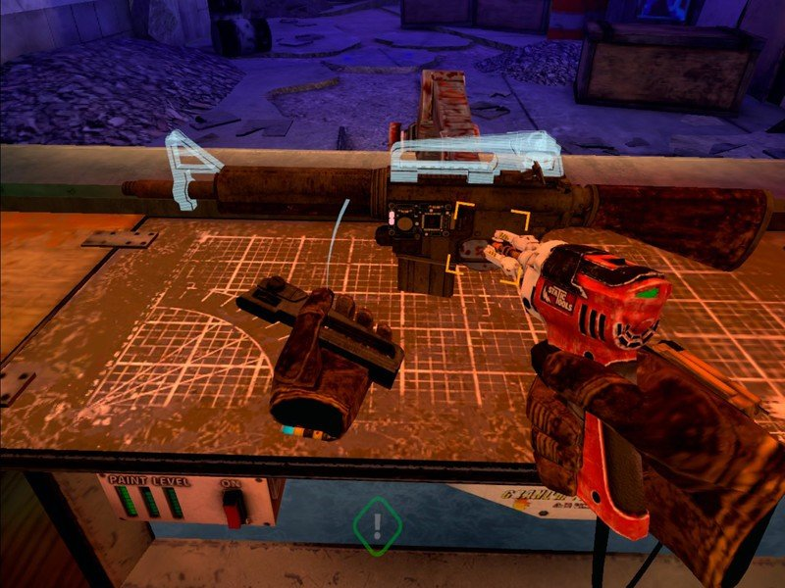

Graphics and Audio

This was my favorite part of the whole experience, now the Quest 2 has it fair share of good and bad graphics but in this case it was good, i couldn't help but feel asif i was in the snowy city fighting ‘’snowies’’ although sometimes visions blurred due to the high intensity fog, it truly makes you feel immersed in the game. The audio is also decent, hearing everything from the gun to the reload, to the zombie behind you ready to attack. It also creeped me out when you could hear them shuffling around in the next room or even up above you, this is where the true scare factor came into place.
If the fog was to be diminished, the city would truly look different and to me would look out of place from what the game truly wants.
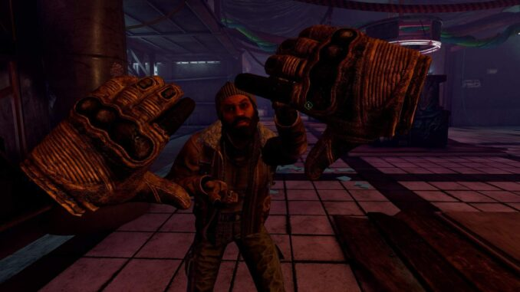
Longevity

As previously stated the game is just a mere 5 runs, as far as different difficulties, and one other game mode this is short for a £29.99 game.
That is this game's downfall, it is simply too short, yes the case may be doing something different the next time but how many times can you do that until it becomes boring… overall this experience is fun for a few hours but can get tedious really quick. That is ultimately its downfall (No pun intended) the longevity is not there for such a promising game.

Final Thoughts

This game is loads of fun and reminded me of the Left 4 Dead days but unfortunately it is such a short game and couldn't get more fun than the first play through. Slaying zombies, brutes and the likes to wondering what to do next.
The game itself has a lot of potential to get so much better but the launch was at least for me disappointing.
That is why im giving this the Thumb Culture Silver Award

